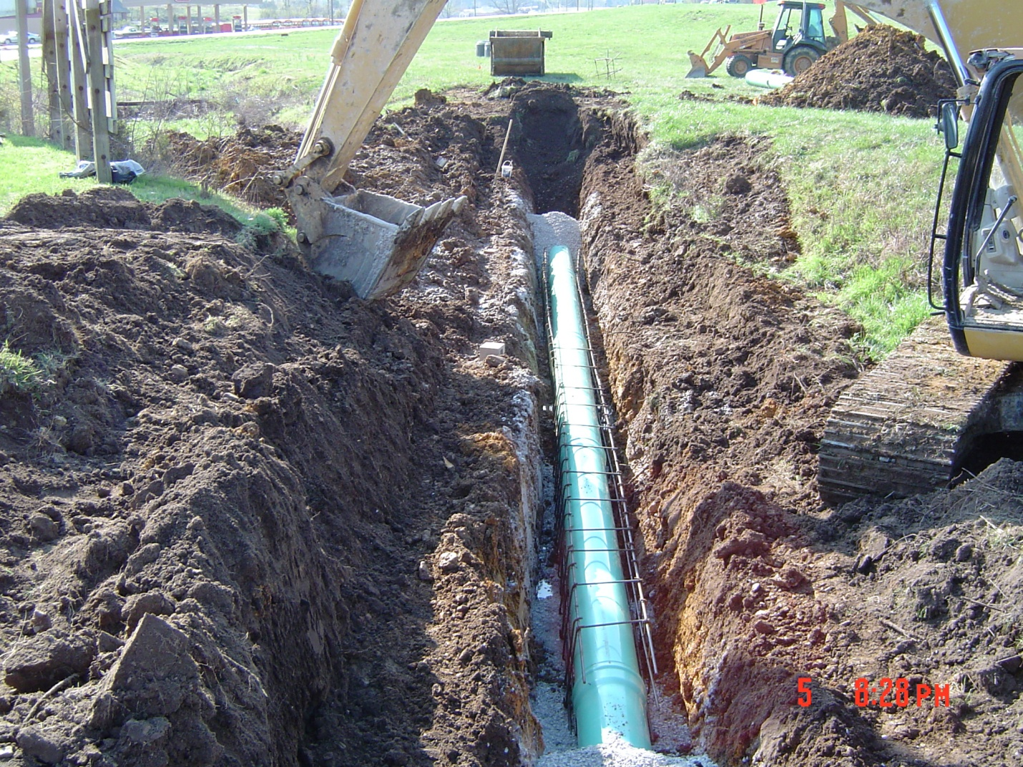

SANITARY SEWER COLLECTION SYSTEM INSPECTION, MAINTENANCE, REPAIR, AND REPLACEMENT PLAN

2012

TABLE OF CONTENTS

- Introduction……………………………………………………………………. 1
  - Goals
  - Sanitary Sewer Overflows
  - Inflow and Infiltration

- Management.…………………………………………………………………... 3
  - System Profile
  - Mapping

- Inspection……………………………………………………….………………5
  - Manholes
  - Lift Stations
  - Sewer Lines

- Maintenance …………………………………………………….…………… ..8
  - Preventive
  - Corrective
  - Emergency
  - Complaint response

- Reporting………………………………………………………………………11
  - Inflow and infiltration
  - Sanitary sewer overflows

- Capital Improvement Program……………………………………..………….12

- Appendices
Appendix 1: Sewer Ordinance
Appendix 2: Building Codes
Appendix 3: Flow Meter Data
Appendix 4: Sanitary Sewer Overflow Policy
Appendix 5: Inspection Forms
Appendix 6: Public Education Articles

1.0 INTRODUCTION
The sewer collection system is designed to carry wastewater through the City’s sewer lines. A vast system of underground sewers collects the wastewater from the homes of the city's residents and businesses and delivers it to their waste water treatment plant. Wastewater discharged from a home or business enters the sewer system through service lines. These service lines carry the flow of wastewater to the City’s trunk lines. Collection systems are built to utilize the natural flow of gravity when possible. When wastewater cannot travel through the lines by gravity, pump stations are utilized.
The sanitary sewer system is an essential component of the City’s infrastructure, so it is important to have a comprehensive inspection, maintenance, repair, and replacement program. Such a program will help ensure that service and reliability are maximized at minimal cost. This Sanitary Sewer Collection System Inspection, Maintenance, Repair, and Replacement Plan has been designed to put into place policies and procedures to prevent, to the greatest extent possible and practicable, sanitary sewer overflows and to keep the system functioning at its highest possible level. This plan was developed using the U.S. EPA’s Guide for Evaluating Capacity, Management, Operation, and Maintenance (CMOM) Programs at Sanitary Sewer Collection Systems (Document #EPA 305-B-05-002).

  - Goals
The goals of this plan are to:

- Reduce frequency and severity of sanitary sewer overflows (SSOs) and their potential impacts on public health, safety, and on the environment.

- Manage the assets of the City of Ava to affect a regular maintenance program and effectively respond to emergency overflows.

- Develop a system to assess and prioritize maintenance, rehabilitation, and replacement activities for the collection system.

- When overflows occur, to ensure that prompt action is taken to identify, contain, remove the cause and promptly report the event to appropriate regulatory authorities.

- Ensure that sewer system operators and employees are adequately trained and equipped to address an overflow event.

1.2 Sanitary Sewer Overflows (SSOs)
Sanitary sewer collection systems have a finite capacity to carry wastewater based on the size and condition of the components. Sanitary sewer overflows occur when increased flows exceed the ability of the system to convey the wastewater to the
wastewater treatment plant. SSOs are overflows, spills, diversions, or release of wastewater from the collection system. A sanitary sewer overflow can result from poor maintenance of the system, equipment failures, increased growth of the community, aging infrastructure, and excessive inflow and infiltration.

1.3 Inflow and Infiltration (I&I)
I&I are terms used to describe ways that groundwater and stormwater enter the sanitary sewer system. Inflow is water that enters the system through improper connections, such as downspouts, broken piping at creek crossings, and groundwater sump pumps. Infiltration is groundwater that enters the system through breaks in the pipes. When stormwater gets into the sanitary sewers it must be moved and treated like sewage. Too much stormwater in the system can cause sewer backups and sanitary sewer overflows after rain events. By reducing I&I the City can reduce operating costs and increase the lifetime of the treatment plant as well as maintain compliance with state and federal water quality regulations. Reduction of I&I is one of the primary purposes of this sewer maintenance plan.

2.0 MANAGEMENT

The City of Ava operates with a Mayor-Council form of government. The city is the local governmental entity tasked with wastewater management within its jurisdiction. Acting in its capacity as a Fourth Class City, the city has enacted ordinances which guide and implement its wastewater management activities. Such ordinances include those addressing planning and zoning, subdivision development, building codes, as well as sewer use, hookups, prohibited discharges, and user fees.
Sewer ordinances have been adopted in accordance with the funding requirements of state and federal assistance programs. Ordinances are kept up-to-date and are available online at www.avamissouri.org. Current ordinances require connection of wastewater generators within 100 feet of the public sewer system, that such connection is constructed to meet applicable building codes and governmental regulations, and that connections be inspected and accepted by the city. The ordinances prohibit connection of downspouts, sump pumps, and foundation drains to the public sewer system. All new pipes and manholes are required to be tested to ensure tightness and prevent future infiltration of stormwater.
The City of Ava builds and maintains the collection system serving a population of 2993 up to the point of connection with individual building drains. The city also builds and maintains the treatment facility.
The wastewater treatment plant and lagoon are maintained by the Wastewater Superintendent and Plant Operator. The sewer collection system is maintained by the Water & Sewer Superintendent, Equipment Operator, and Water & Sewer Laborer. The Superintendents answer directly to the Mayor. Maintenance decisions are made mainly at the supervisory level of the department involved, with general approval and direction of the Mayor. Safety training is performed within each department on a regular basis. Response to emergency situations is initiated by the appropriate department Superintendent.
The Water & Sewer Superintendent is required to have a DS-III Distribution Certification before making operational decisions. The Wastewater Superintendent must have a Class B Wastewater Certification and the Plant Operator is required to have a Class D Wastewater Certification. All water and wastewater employees are required to have training in:
Personal protective equipment
Lock-out, tag-out
Trenching and shoring
Confined space entry
Hazard communication
Blood borne pathogens.

2.1 System Profile
The City of Ava owns and operates the only centralized wastewater management system in the jurisdiction. Of the approximately 25 miles of pipe in the

existing sewer system, approximately 24 miles operate as gravity sewers, and the remainder operates as four-inch force main pressurized by a pump station.
The Ava collection system is comprised primarily of eight inch laterals which tie into either one of the larger interceptor sewers or the wet well of a pumping station. The major interceptor sewers, ranging in size from 12 inch to 20 inch, are located in the southwest area of the City and are directly tributary to the existing WWTP.
There are approximately 209 inch-miles of gravity sewer in the collection system. There are approximately 440 manholes in the system with an average spacing of 288 feet. Sewer depths vary but are generally less than ten feet.
The oldest sewers were installed from 1935 through 1937. These sewers are of VCP construction and were installed by hand without bedding. The next major sewer construction occurred in 1960. These sewers are primarily of VCP construction also, and manholes are of brick and mortar construction. In 1987 another major sewer project was conducted of primarily PVC construction with some DIP and RCP sewers, and pre-cast concrete manholes. The most recent sewer project was completed in 2003 of PVC pipe and concrete manholes.
It is estimated that there are approximately thirteen miles of private building service lines connected to the public sewer system. This estimate is based on 50 feet of building sewers for each of the 1350 housing units.
There are currently three pumping stations located in the collection system. Lift Station No. 2 is a duplex submersible non-clog pumping station with a rated capacity of 128 gpm at 102 ft TDH. There are also two duplex submersible grinder pump stations each with a rated capacity of 31 gpm at 55 ft TDH that discharge into the four-inch force main serving Lift Station No. 2.

2.2 Mapping
An essential component of a successful sewer collection system maintenance plan is an accurate map of the system. The City maintains a GIS mapping program that includes GPS coordinates for manholes and lift stations. Using this map the City will divide the collection system into designated areas that will be prioritized based on known problem areas with a schedule to inspect the lines in a specified area. Sewer lines that were installed in the last twenty years may be excluded from the schedule unless there is a reason to believe they are a major source of I&I.

3.0 INSPECTION

This program has a schedule that ensures that the entire collection system is inspected every ten years or less. Inspection of the collection system may include smoke testing, flow metering, dye injection, camera inspection of the sewer lines, as well as manhole and lift station inspections.

3.1 Manhole Inspections
There are approximately 440 manholes in the system, each with an identifying number. The City plans to work with the Missouri Public Utility Alliance to inspect all manholes before January 2013. A Manhole Inspection Report will be completed for each inspection and each manhole will be photographed. Manholes will be rated according to condition and listed as priority one, two, or three. Results from the inspection activities will form the basis for a majority of the scheduled maintenance in following years. As manhole inspections are conducted, crews will report any inconsistencies between manhole locations and the GIS mapping system.

3.2 Lift Station Inspections
There are three lift stations in the system. Each lift station will be inspected at least once a week for general condition. Each station will be drained and thoroughly inspected four times per year according to the schedule in Table 3A. The Lift Station Inspection Worksheet will be completed during regularly scheduled inspections.

January | Lift Station #1
February | Lift Station #2
March | Lift Station #3
April | Lift Station #1
May | Lift Station #2
June | Lift Station #3
July | Lift Station #1
August | Lift Station #2
September | Lift Station #3
October | Lift Station #1
November | Lift Station #2
December | Lift Station #3
Table 3A

3.3 Sewer Line Inspections
There are approximately 25 miles of sewer collection lines in the system. The city is currently in the process of inspecting the collection system with flow meters to determine areas of concern for inflow and infiltration. Once these areas have been narrowed down, additional testing will be used to further delineate the areas of concern. These inspections will form the basis for scheduled maintenance activities. Types of inspections may include:

Flow meters: The City of Ava owns two Sigma 950 flow meters from Hach Company using Insight software. The City conducted flow monitoring in 2000. However, irregularities in the results made the data collected inconclusive. The meters were refurbished in 2011 and reinstalled at two locations. Data was collected from June 1 through June 5, 2011 and August 20 through August 22, 2011. Data collected over these dates appears to be accurate.
The City will continue to collect data from all parts of the City using the Hach flow meters. The meters will be placed in strategic locations to identify major areas of I&I infiltration and to indicate where additional testing is needed.
Rainfall data will be collected for the periods covered by flow metering. Dry weather flows will be compared to peak flows following rainfall events. Areas with high peaking factors will be considered high priority.

Smoke testing: The City will conduct smoke testing of the system as necessary to identify public and private sources of inflow. The City owns smoke testing equipment and sewer personnel have the skills to conduct the tests. Either City personnel or contract workers will conduct smoke testing. It is expected that much of the inflow will be found on private property from downspouts, sump pumps, and foundation drains. Notification to property owners will be made prior to beginning the smoke testing. Property owners will be encouraged to immediately correct illegal connections consistent with the City’s sewer use ordinance. All sources of inflow will be documented.

Video inspection: Once the major areas of concern are located by the use of flow meters, the City may choose to conduct camera inspections of the lines to further isolate problems of infiltration based on a cost-effectiveness analysis to determine if the infiltration into the system is excessive. The camera inspections will capture actual line conditions and create a video record of the pipe conditions. Inspections will look for grease build-up, obstructions, reverse slope, dips in the line, root intrusion, and will note pipe

characteristics and structural condition. Sources of infiltration will be documented. Sewer main repair or replacement schedules will depend on the results of the video inspection program.
The scope of the program might include all of the above steps, but the magnitude
of the effort for each step will depend on the findings of prior investigations. The
purpose of proceeding sequentially is to undertake the program in the most
economical way. For example, flow monitoring should help narrow down the area to be smoke tested and repairs to manholes may eliminate the need for video inspection of lines.

3.4 Building Inspections
Building inspections provide a positive way to identify buildings with a sump pump, downspout, or foundation drain discharging to the sanitary sewer system. Inspections will be made in areas where smoke testing indicates the likelihood of these connections. Knowledge of the building practices when the homes were constructed is also helpful in deciding which areas merit building inspections. Once the inspections are made, follow-up enforcement is usually required to assure that disconnection of the prohibited connection takes place.
Building inspections will require extensive public education, including newspaper articles, radio interviews, and phone calls. Inspectors will have to be trained in dealing with the public, answering the resident’s questions, and documenting the results of the inspection. Official identification badges will be provided each inspector so the public can feel secure with letting the inspectors into their residence.

4.0 MAINTENANCE

4.1 Preventative
A preventative maintenance program is a systematic approach to performing maintenance activities so that equipment failure is avoided. A good preventative maintenance program will reduce equipment repair and replacement costs and help reduce SSOs.
Preventative maintenance will be scheduled according to the equipment manufacturer and the needs of the City. This schedule will be augmented by knowledge and experience of the collection system operators to reflect site-specific requirement. Equipment will be monitored for early warning signs of impending failure, such as vibration or leakage. Components that are essential to proper system functions will follow the strictest maintenance programs.

4.2 Corrective
The primary sewer maintenance activity is sewer line cleaning to remove accumulated material from the sewer. Cleaning helps to prevent blockages and is also used to prepare the line for inspections.
Pipe sections on a priority cleaning frequency are identified based on known problem areas that have a history of blockages due to sediment, roots, debris, or grease. Critical service area, or those locations where sewer malfunction would lead to major disruption, are inspected and cleaned at greater frequency due to the importance of their function. The sewer department will clean at least two miles of sewer line each month so that the entire system is cleaned each year.
The majority of the routine maintenance activities will be scheduled according to the findings of the inspection activities. Corrective maintenance needs will be prioritized into three groups based on their potential to result in a sanitary sewer overflow.
Low risk items, such as light bulbs, are planned to be replaced when they fail. High risk items must be addressed more quickly. Corrective maintenance will be scheduled immediately after inspection activities reveal an imminent problem that must be corrected to avoid an emergency situation. Some of these repairs are handled under the operations and maintenance account and some must be put in as capital improvements as part of the asset management activities depending on the asset cost and life expectancy.
An essential component of an effective sewer cleaning program is accurate recordkeeping. Accurate recordkeeping provides the collection system operators with information on the areas of the system susceptible to stoppages so that an appropriate cleaning schedule can be developed. Each line segment cleaned will be identified by an upstream and downstream manhole number.

Records of cleaning activities will include:
- Date, time, and location of activity;
- Specific lines cleaned;
- Equipment used;
- Identity of cleaning crew;
- Presence of root, grease, or debris; and
- Problems identified or other follow up actions necessary.

Equipment: The City owns a trailer mounted 747FR-2000 “Rotator Jet” jet rodder for sewer line cleaning.

Fats, oils, and grease (FOG): Grease and similar products can significantly increase the likelihood of sewer overflows. The City of Ava sewer use ordinance prohibits discharge of grease to the sewer collection system. Following a significant grease removal effort several years ago, the city personnel regularly check for grease in the system to ensure that food service establishments are conducted regular grease trap maintenance. To date this program has been effective in reducing blockages due to grease.

Easements: Easements give the City the right to install and maintain sewer and water facilities on property not owned by the City and are important for the operation and maintenance of the collection system. The City’s goal is that all easements remain clear of any buildings, trees, and extensive landscaping to allow equipment access for maintenance of the collection system. The City is not liable to repair or replace any such items that are removed in the process of completing repairs or maintenance of the system. Crews, however, work with the property owner whenever possible.

4.3 Emergency
Emergency maintenance activities are outside of the regularly scheduled maintenance activities. Emergency maintenance occurs when a piece of equipment or system fails, creating a threat to human health or environment. Examples of emergency situations include a lift station failure or broken force main. These activities follow the City’s procedure for remediating emergency situations. Emergency maintenance activities are initiated by the collection system superintendent or the on-call staff.

4.4 Complaint response
Information from a citizen reporting a sewer complaint will generate a work order. Complaint response includes both assessing the complaint and resolving the problem. Response to a sewer complaint may require emergency maintenance to be conducted to
remedy the situation. Sewer compliant reports will be evaluated on a regular basis to assess performance, identify new areas of concern, and update this plan.
While the City of Ava maintains sewer mains, the service lateral from the building drain to the sewer main is the owner’s responsibility. If a complaint is received and the City’s field crew determines that the problem is the result of blockage or a collapse in the portion of the lateral under the property owner’s responsibility, the property owner will be notified of such.

5.0 REPORTING

5.1 Inflow and Infiltration
The City will keep records of I&I incidents and prevention activities. Efforts to reduce I&I into the system will be reported to the Department of Natural Resources annually as required by the City’s wastewater treatment plant permit.

5.2 Sanitary Sewer Overflows
The City is required to report all SSOs to the Missouri Department of Natural Resources within 24 hours and follow up with a written report within five days unless waived by the Department. Reports will include, at a minimum, the following information:

- Date and time (best estimate) of the event.
- Precipitation data (including intensity and duration).
- Source of the information (citizen complaint, observation, etc.).
- Location of the SSO.
- Duration of the discharge (estimate or monitored).
- Best estimate of the volume discharged.
- Sampling results from any sampling performed.
- Identification of the water body to which the wastewater was released.
- Cause of the discharge.
- Measures taken to respond to the discharge.
- Date and time of repairs.
- Measures taken to prevent reoccurance.
- Date and time of Notification to the DNR Regional Office.

The City will establish an SSO tracking and management system that is effective and collects useful information and that can be used for long term maintenance of the system.

6.0 CAPITAL IMPROVEMENTS PROGRAM

The Capital Improvements Program (CIP) identifies projects, equipment purchases, and options for financing. When setting short and long term goals for the sewer system it is essential to have a capital improvements program in place to ensure that the budget reflects those priority needs.
The CIP encourages careful project planning, focuses attention on community objectives, helps identify the most economical means of financing projects, and enhances the community’s credit rating. The purpose of the CIP is the make certain that the City is financially prepared to implement the sewer maintenance program. The CIP is designed to assess projected needs for maintaining the integrity of the collection system and expanding sewer capacity to accommodate growth.
The CIP is based on a ten-year period and is updated annually. It includes items with a higher initial cost and projected life span, such as inspection equipment, sewer main repair, and sewer capacity projects.
The City recently completed a sewer rate analysis which indicated a need for increased rates. This increase will be implemented over a period of ten years in order to avoid large one-time pay rate increases.
Items currently on the Capital Improvements Program priority list are:

Equipment:
$40,000 Backhoe replacement
$30,000 Truck #4 replacement
$6,000 Dump truck (used)
$75,000 Jetrodder replacement
$3,500 Smoke testing equipment
$3,000 Hose replacement for jetrodder
$6,000 Camera equipment for jetrodder
$400 Trash pump

Collection system replacement:
$100,000 Manhole replacement and rehabilitation
$100,000 Line replacement and repair
$250,000 NE 6th Ave to FF Hwy and 15th St
$40,000 NE 3rd Ave extension
$6,000 NE 13th Ave Terrace
$60,000 E 14 Hwy
$50,000 NW 9th St

The City will review sewer rates annually, compare them with the budget, and make adjustments as necessary. The primary goal of the CIP is the address long term improvements instead of regular maintenance and immediate repairs. Projects will be prioritized on the basis of need, regulatory requirements, and available finances. Each project will be evaluated for benefits per unit of cost and the projected effect on user rates.
An important component of the capital improvements program is identification of possible funding sources. Some of these purchases will be beyond the capacity of the current sewer rates and may require a rate increase. Long-term financing may be necessary and can include issuance of general obligation or revenue bonds. Some projects may qualify for state or federal grants or loans.

